
Work Instruction for Customization of the sudoers file

Viatris
Work Instruction for Customization of the sudoers file

Contents
Contents 2
1. Introduction 3
1.1. Purpose 3
1.2. Scope of this Report 3
1.3. Audience 3
2. Approach and Methodology 3
2.1. Approach 3
2.1.1. Create a Change Request 3
3. Technical Details 3
3.1. Editing the Sudoers File 3
3.2. Validating Changes 4
4. Available Customized Sudo groups 4
4.1. Zenvtm 4
4.2. cyberark 5
4.3. splunkfwd 5
4.4. nbu-admin 5
4.5. nbu-user 8
4.6. nbu-patching 9
4.7. zenrims 9
4.8. fits 10
5. Roles and Responsibilities 11
6. Escalation Matrix 11
6. Revision History 11

1. Introduction

1.1. Purpose
This document provides the steps to Customization of the sudoers file.

1.2. Scope of this Report
The scope of this document is to describe how to Customize of the sudoers file.

1.3. Audience
GIDC UNIX Group

2. Approach and Methodology

Approach

2.1.1. Create a Change Request
- Create a Change Request (CR) in ServiceNow for Customization of the sudoers file.

Technical Details

Editing the Sudoers File
  - Login to the desired server using MID and password and switch to root user using sudo su – command.
  - Before making changes, create a backup of the sudoers file:
# cp -rp /etc/sudoers /etc/sudoers_`date +%F`
  - File needs to be created under /etc/sudoers.d path.
  - Always use the visudo command to edit the sudoers file. This ensures syntax validation and prevents accidental misconfiguration.
# visudo
  - To allow a user to execute only specific commands, provide the full path of the command:
# %zenvtm ALL = (ALL) /usr/bin/yum, /bin/yum, /usr/sbin/subscription-manager list,
  - To allow all users in a group (groupname) to execute commands as any user:
# %zenvtm ALL = (ALL)

Validating Changes
  - When using visudo, it automatically checks the syntax.
  - Log in as the user and test the commands they are permitted to execute:
# sudo -l

Available Customized Sudo groups

Zenvtm
- The commands customized for zenvtm group:

%zenvtm ALL = (ALL) /usr/bin/yum, /bin/yum, /usr/sbin/subscription-manager list, /sbin/subscription-manager list, /usr/bin/systemctl status *, /sbin/service * status, /usr/bin/rpm, /bin/rpm, /usr/bin/systemctl stop besclient.service, /usr/bin/systemctl start besclient.service, /usr/bin/systemctl restart besclient.service, /sbin/service besclient start, /sbin/service besclient stop, /sbin/service besclient restart, /usr/bin/mount, /usr/bin/umount, /usr/sbin/shutdown, /usr/sbin/reboot, /usr/sbin/ip, /usr/bin/chronyc, /usr/sbin/vgdisplay, /usr/sbin/pvdisplay, /usr/sbin/lvdisplay, /usr/bin/cp /etc/fstab *, /usr/bin/vi /etc/fstab, /usr/bin/vi /etc/resolv.conf, /usr/bin/teamdctl, /usr/bin/crontab, /usr/bin/curl, /usr/sbin/dmidecode, /usr/bin/systemctl start chronyd.service, /usr/bin/systemctl stop chronyd.service, /usr/bin/systemctl restart chronyd.service, /usr/sbin/route, /usr/bin/nmcli connection show, /usr/sbin/ifup, /usr/sbin/ifdown, /usr/bin/SUSEConnect --status, /usr/bin/zypper, /usr/bin/journalctl, /usr/bin/cat /var/log/messages*, /usr/bin/tail /var/log/messages*, /usr/bin/less /var/log/messages*, /usr/bin/more /var/log/messages*, /usr/bin/grep /var/log/messages*, /usr/bin/cat /var/log/dnf*, /usr/bin/tail /var/log/dnf*, /usr/bin/less /var/log/dnf*, /usr/bin/more /var/log/dnf*, /usr/bin/grep /var/log/dnf*, /usr/admin/RedCloak/LINUX_srv_detail_script1.sh, /usr/bin/cd /var/opt/BESClient/__BESData/__Global/Logs/, /usr/bin/cd /var/opt/BESClient/EDRDeployData/, /usr/bin/ls /var/opt/BESClient/__BESData/__Global/Logs/, /usr/bin/ls /var/opt/BESClient/EDRDeployData/, /usr/bin/cat /var/opt/BESClient/__BESData/__Global/Logs/*, /usr/bin/cat /var/opt/BESClient/EDRDeployData/*

%zenvtm ALL = (ALL) !/usr/bin/vi /etc/ssh/sshd_config, !/usr/bin/vi /etc/sudoers.d/zenvtm, !/usr/bin/vi /etc/group, !/usr/bin/su -, !/usr/bin/cd /etc/sudoers.d, !/usr/bin/vi /etc/sudoers, !/usr/sbin/useradd, !/usr/sbin/usermod, !/usr/bin/vi /etc/passwd, !/usr/bin/vi /etc/shadow

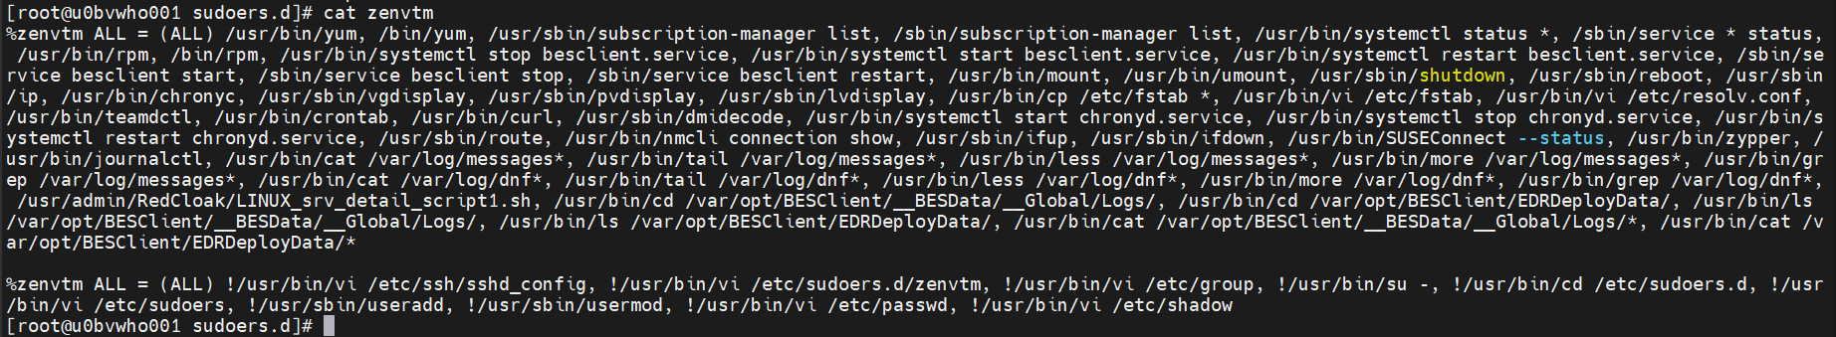

Cyberark
  - The commands customized for cyberark group:

%cyberarkadm ALL = (ALL) /usr/sbin/useradd calogon, /usr/sbin/useradd carecon, /usr/bin/passwd calogon, /usr/bin/passwd carecon, /usr/bin/passwd -S calogon, /usr/bin/passwd -S carecon, /usr/bin/chage --list calogon, /usr/bin/chage --list carecon
carecon ALL=(ALL) /usr/bin/passwd [A-z]*, /usr/bin/sudo passwd [A-z]*, /usr/bin/whoami

Splunkfwd
  - The commands customized for splunkfwd group:
%splunkfwd ALL=(ALL) /opt/splunkforwarder/bin/splunk *, /usr/bin/chown -R splunkfwd.splunkfwd /opt/splunkforwarder, /usr/bin/chmod -R 755 /opt/splunkforwarder, /usr/bin/systemctl * SplunkForwarder*

nbu-admin
  - The commands customized for nbu-admin group:

%ux-nbu-admin ALL=(ALL) /usr/openv/netbackup/bin* ,/usr/openv/netbackup/bin/* ,/usr/openv/netbackup/bin/goodies/* ,/usr/openv/netbackup/bin/goodies/support/* ,/usr/openv/netbackup/bin/goodies/man/* ,/usr/openv/netbackup/bin/goodies/nbhealthcheck/* ,/usr/openv/netbackup/bin/goodies/mediascripts/* ,/usr/openv/netbackup/bin/admincmd/* ,/usr/openv/netbackup/bin/private/* ,/usr/openv/netbackup/bin/support/* ,/usr/openv/netbackup/bin/support/config/* ,/usr/openv/netbackup/bin/support/output/* ,/usr/openv/netbackup/bin/support/output/nbcc/* ,/usr/openv/netbackup/bin/support/input/* ,/usr/openv/netbackup/bin/support/input/nbccr/* ,/usr/openv/netbackup/bin/support/input/nbccr/SRA/* ,/usr/openv/netbackup/bin/cluster/* ,/usr/openv/netbackup/bin/cluster/util/* ,/usr/openv/netbackup/bin/cluster/vcs/* ,/usr/openv/netbackup/bin/driver/* ,/usr/openv/netbackup/bin/driver/scst/* ,/usr/openv/netbackup/bin/malwarescanner/* ,/usr/openv/netbackup/bin/malwarescanner/AMD64/* ,/usr/openv/netbackup/bin/malwarescanner/linuxR_x86/* ,/usr/openv/netbackup/bin/malwarescanner/linuxS_x86/* ,/usr/openv/netbackup/bin/bpdbm_child/* ,/usr/openv/netbackup/bin/bpdbm_parent/* ,/usr/openv/netbackup/bin/bprd.d/* ,/usr/openv/netbackup/bin/bpsched.d/* ,/usr/openv/netbackup/bin/bprd_child/* ,/usr/openv/netbackup/bin/bprd_parent/* ,/usr/openv/netbackup/sec/at/bin* ,/usr/openv/netbackup/sec/at/bin/* ,/usr/openv/netbackup/sec/at/lib/* ,/usr/openv/netbackup/sec/az/bin/* ,/usr/openv/netbackup/sec/az/lib/* ,/usr/openv/netbackup/sec/az/lib/dtd/* ,/usr/openv/netbackup/web/asset_providers/lib/* ,/usr/openv/wmc/bin* ,/usr/openv/wmc/bin/* ,/usr/openv/wmc/bin/install/* ,/usr/openv/wmc/webserver/bin/* ,/usr/openv/wmc/webserver/lib/* ,/usr/openv/wmc/lib/* ,/usr/openv/wmc/asset_providers/lib/* ,/usr/openv/lib* ,/usr/openv/lib/* ,/usr/openv/lib/map/* ,/usr/openv/lib/map/rvp/* ,/usr/openv/lib/vxfi/* ,/usr/openv/lib/vxfi/data/* ,/usr/openv/lib/vxfi/providers/* ,/usr/openv/lib/boost/* ,/usr/openv/lib/ost-plugins/* ,/usr/openv/lib/ost-plugins/zapi/* ,/usr/openv/lib/psf-plugins/* ,/usr/openv/lib/psf-plugins/Nutanix-AHV/* ,/usr/openv/lib/psf-plugins/hadoop/* ,/usr/openv/lib/psf-plugins/hbase/* ,/usr/openv/lib/psf-plugins/openstack/* ,/usr/openv/lib/psf-plugins/third-party/* ,/usr/openv/lib/psf-plugins/azurestack/* ,/usr/openv/lib/psf-plugins/mongodb/* ,/usr/openv/lib/psf-plugins/cassandra/* ,/usr/openv/lib/shared/* ,/usr/openv/lib/shared/vddk/* ,/usr/openv/lib/shared/vddk/lib64/* ,/usr/openv/lib/shared/vddk/bin64/* ,/usr/openv/lib/plugins/* ,/usr/openv/java/jre/bin* ,/usr/openv/java/jre/bin/* ,/usr/openv/java/jre/lib/* ,/usr/openv/java/jre/lib/amd64/* ,/usr/openv/java/jre/lib/amd64/jli/* ,/usr/openv/java/jre/lib/amd64/server/* ,/usr/openv/java/jre/lib/applet/* ,/usr/openv/java/jre/lib/cmm/* ,/usr/openv/java/jre/lib/ext/* ,/usr/openv/java/jre/lib/fonts/* ,/usr/openv/java/jre/lib/images/* ,/usr/openv/java/jre/lib/images/cursors/* ,/usr/openv/java/jre/lib/jfr/* ,/usr/openv/java/jre/lib/management/* ,/usr/openv/java/jre/lib/oblique-fonts/* ,/usr/openv/java/jre/lib/security/* ,/usr/openv/java/jre/lib/security/policy/* ,/usr/openv/java/jre/lib/security/policy/limited/* ,/usr/openv/java/jre/lib/security/policy/unlimited/* ,/usr/openv/pdde/pdshared/lib/* ,/usr/openv/pdde/pdag/bin/* ,/usr/openv/pdde/pdag/bin/.bin/* ,/usr/openv/pdde/pdopensource/bin/* ,/usr/openv/pdde/pdopensource/bin/.bin/* ,/usr/openv/pdde/pdopensource/lib/* ,/usr/openv/pdde/vpfs/bin* ,/usr/openv/pdde/vpfs/bin/* ,/usr/openv/pdde/vpfs/bin/.bin/* ,/usr/openv/pdde/vpfs/lib/* ,/usr/openv/pdde/vpfs/tools/bin/* ,/usr/openv/pdde/vpfs/tools/bin/.bin/* ,/usr/openv/pdde/vpfs/tools/lib/* ,/usr/openv/pdde/pdcr/bin/* ,/usr/openv/pdde/pdcr/bin/.bin/* ,/usr/openv/db/bin* ,/usr/openv/db/bin/* ,/usr/openv/db/lib* ,/usr/openv/db/lib/* ,/usr/openv/mqbroker/bin* ,/usr/openv/mqbroker/bin/* ,/usr/openv/mqbroker/bin/goodies/* ,/usr/openv/mqbroker/bin/install/* ,/usr/openv/mqbroker/erlang/bin/* ,/usr/openv/mqbroker/erlang/lib/* ,/usr/openv/volmgr/bin/* ,/usr/openv/volmgr/bin/goodies/* ,/opt/VRTSpbx/* ,/opt/VRTSpbx/bin* ,/opt/VRTSpbx/bin/* ,/opt/VRTSpbx/bin/cluster/* ,/opt/VRTSpbx/lib* ,/opt/VRTSpbx/lib/* ,/opt/VRTSpbx/man/* ,/opt/VRTSpbx/man/man1/* ,/opt/VRTSpbx/resources/* ,/opt/VRTSpbx/resources/VxPBX/* ,/opt/VRTSpbx/resources/vxul/* ,!/bin/su - ,/usr/bin/ls ,/usr/bin/df ,/usr/bin/du ,/usr/bin/vi /usr/openv/java/auth.conf
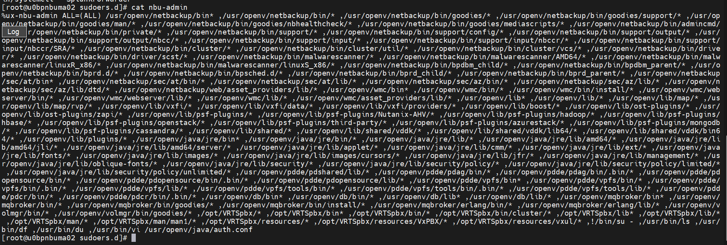

nbu-user
  - The commands customized for nbu-user group:
%ux-nbu-user ALL=(ALL) /usr/openv/netbackup/bin/bpclntcmd ,/usr/openv/netbackup/bin/admincmd/bpdbjobs ,/usr/openv/netbackup/bin/admincmd/bperror,/usr/openv/netbackup/bin/admincmd/bpflist ,/usr/openv/netbackup/bin/admincmd/bpgetconfig ,/usr/openv/netbackup/bin/admincmd/bpimagelist ,/usr/openv/netbackup/bin/bplist ,/usr/openv/netbackup/bin/admincmd/bpplinfo ,/usr/openv/netbackup/bin/admincmd/bppllist ,/usr/openv/netbackup/bin/bpps ,/usr/openv/netbackup/bin/admincmd/bpstsinfo ,/usr/openv/netbackup/bin/admincmd/bptestbpcd ,/usr/openv/netbackup/bin/bptestnetconn ,/usr/openv/netbackup/bin/support/NBCC ,/usr/openv/netbackup/bin/nbcertcmd ,/usr/openv/db/bin/nbdb_ping ,/usr/openv/netbackup/bin/admincmd/nbdevquery ,/usr/openv/netbackup/bin/support/nbsu ,!/bin/su - ,/usr/bin/ls ,/usr/bin/df ,/usr/bin/du

nbu-patching
  - The commands customized for nbu-patching group:
%ux-nbu-patching ALL=(ALL) /usr/openv/netbackup/bin/bp.start_all, /usr/openv/netbackup/bin/bp.kill_all, /opt/VRTSpbx/bin/vxpbx_exchanged, /usr/openv/netbackup/bin/goodies/netbackup, /usr/openv/netbackup/bin/bpps, /usr/openv/netbackup/bin/bptestnetconn, /usr/openv/netbackup/bin/admincmd/bptestbpcd, /usr/openv/netbackup/bin/nbcertcmd, /usr/openv/db/bin/nbdb_ping, /usr/openv/netbackup/bin/support/nbsu, /usr/openv/netbackup/bin/bpclntcmd, /opt/SYMCOpsCenterServer/bin/opsadmin.sh, /dpa/services/bin/*, !/bin/su -, /usr/bin/ls, /usr/bin/df, /usr/bin/du

zenrims
  - The commands customized for zenrims group:
%zenrims ALL = (ALL) /usr/sbin/service ennov status, /usr/sbin/service ennov start, /usr/sbin/service ennov stop, /usr/sbin/service ennov restart, /usr/bin/systemctl status ennov, /usr/bin/systemctl start ennov, /usr/bin/systemctl stop ennov, /usr/bin/systemctl restart ennov, /usr/bin/systemctl enable ennov, /usr/bin/systemctl disable ennov , /usr/sbin/service ennov-solr status, /usr/sbin/service ennov-solr start, /usr/sbin/service ennov-solr stop, /usr/sbin/service ennov-solr restart, /usr/bin/systemctl status ennov-solr, /usr/bin/systemctl start ennov-solr, /usr/bin/systemctl stop ennov-solr, /usr/bin/systemctl restart ennov-solr, /usr/bin/systemctl enable ennov-solr, /usr/bin/systemctl disable ennov-solr

fits
  - The commands customized for fits group:
%ux-fits-admin ALL = (ALL) /usr/bin/rm -r /app/fits/frontend/dist/, /usr/bin/rm -f /app/fits/frontend/dist.zip, /usr/bin/unzip /app/fits/frontend/dist.zip, /usr/bin/cp /fits_bkp/gaoqiang.Li/deploy/isales-gateway.jar /app/fits/backend/, /usr/bin/cp /fits_bkp/gaoqiang.Li/deploy/isales-auth.jar /app/fits/backend/, /usr/bin/cp /fits_bkp/gaoqiang.Li/deploy/isales-system.jar /app/fits/backend/, /usr/bin/cp /fits_bkp/gaoqiang.Li/deploy/isales-incentive.jar /app/fits/backend/, /usr/bin/cp /fits_bkp/gaoqiang.Li/deploy/dist.zip /app/fits/frontend/, /usr/bin/cp -r /fits_bkp/gaoqiang.Li/deploy/dist/ /app/fits/frontend/, /usr/bin/sh /app/fits/backend/startup-gateway.sh, /usr/bin/sh /app/fits/backend/startup-auth.sh, /usr/bin/sh /app/fits/backend/startup-system.sh, /usr/bin/sh /app/fits/backend/startup-incentive.sh, /usr/bin/sh /app/fits/monitor/startup-auto.sh, /usr/bin/sh /app/fits/backend/shutdown-gateway.sh, /usr/bin/sh /app/fits/backend/shutdown-auth.sh, /usr/bin/sh /app/fits/backend/shutdown-system.sh, /usr/bin/sh /app/fits/backend/shutdown-incentive.sh, /usr/bin/sh /app/fits/monitor/shutdown-auto.sh, /usr/bin/java -jar /app/fits/backend/isales-gateway.jar, /usr/bin/java -jar /app/fits/backend/isales-auth.jar, /usr/bin/java -jar /app/fits/backend/isales-system.jar, /usr/bin/java -jar /app/fits/backend/isales-incentive.jar, /usr/bin/java -jar /app/fits/monitor/auto-0.0.1-SNAPSHOT.jar, /usr/bin/vi /app/fits/nginx-1.20.2/conf/nginx.conf, /usr/bin/systemctl restart nginx, /app/fits/nginx-1.20.2/objs/nginx, /app/fits/nginx-1.20.2/objs/nginx -c /app/fits/nginx-1.20.2/conf/nginx.conf, /app/fits/nginx-1.20.2/objs/nginx -t, /usr/bin/sh /fits_bkp/nacos/bin/startup.sh -m standalone, /app/fits/redis/redis-6.2.5/src/redis-server, /usr/bin/find

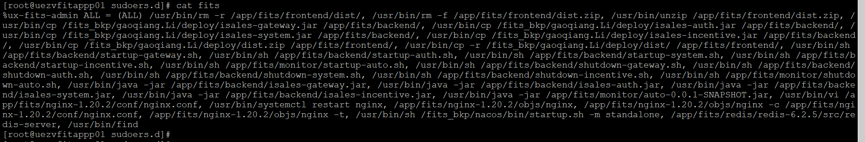

Roles and Responsibilities
Sl. No. | Roles | Responsibilities | Team Member Name
1. | Change Request | Respective Team / Unix Team | GIDC.unix_Run  GIDC.unix_Run@viatris.com
2. | Change Implementation | Respective Team / Unix Team | GIDC.unix_Run  GIDC.unix_Run@viatris.com

Escalation Matrix
Person Responsible | Role | Triggers When
Arun R  Arun.R@viatris.com  +91 9710677240 | Deputy Manager
Ashok Kumar R K  AshokKumar.RK@viatris.com  +91 9967735890 | Senior Manager
Zahir Hussain M ZahirHussain.M@viatris.com  +91 9840689462 | Senior Manager

6. Revision History

Date | Version | Summary of Changes | Author | Approved by
April 28 2025 | V1.0 | Created the Document | Benesh Selva Nesan P | Arun R
April 28 2026 | V1.1 | Validated the Document | Benesh Selva Nesan P | Arun R

